**Statistics Library Demo – Project 2**

**Anthony D’Alessandro**

**Table of Contents**

Hypergeometric Distribution……………………………………………………...………………1

Probability…………………………………………………………………………………1

Expected Value…………………………………………………………………………….1

Variance……………………………………………………………………………………2

Standard Deviation………………………………………………………………………...2

Poisson Distribution…………………………………………………….………………...…….....3

Probability…………………………………………………………………………………3

Expected Value and Variance……………………………………………………………...3

Standard Deviation………………………………………………………………………...4

Chebyshev’s Theorem……………………………………………………………………………..4

Probability Given Standard Deviation…………………………………………………….4

Probability Given Variance………………………………………………………………..5

Uniform Distribution…………………………………………………………..………………….5

Probability…………………………………………………………………………………5

Expected Value…………………………………………………………………………….6

Variance……………………………………………………………………………………6

Standard Deviation………………………………………………………………………...7

Hypergeometric Distribution

Probability

* Given the number of successes in sample y = 2, population N = 10, sample size n = 5, and number of successes in the population r = 4

Output:

Hypergeometric Distribution Method:

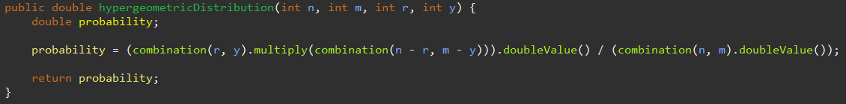

Expected Value

* Given the population N = 10, sample size n = 5, and number of successes in the population r = 4

Output:

Expected Value Method:

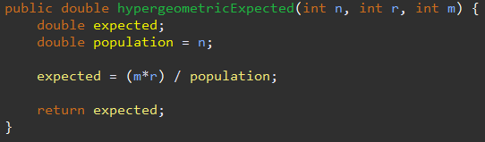

Variance

* Given the population N = 10, sample size n = 5, and number of successes in the population r = 4

Output:

Variance Method:

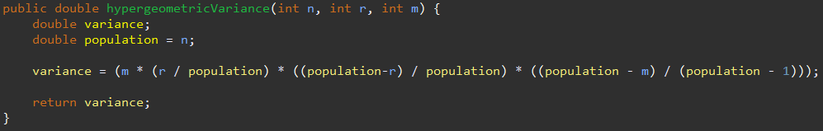

Standard Deviation

* Given the population N = 10, sample size n = 5, and number of successes in the population r = 4

Output:

Standard Deviation Method:

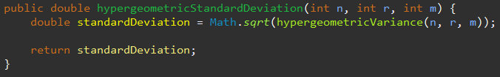

Poisson Distribution

Probability

* Given the average number of events lambda = 2 and the number of occurrences of an event y = 4

Output: 

Poisson Distribution Method:

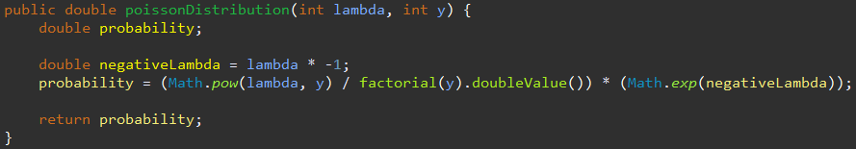

Expected Value and Variance

* Given the average number of events lambda = 2

Output:

Expected Value and Variance Method:



Standard Deviation

* Given the average number of events lambda = 2



Output:

Standard Deviation Method:

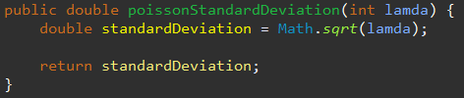

Chebyshev’s Theorem

Probability Given Standard Deviation

* Given a lower range of 16, upper range of 24, mean = 20, and standard deviation = 2

Output:

Chebyshev Method:

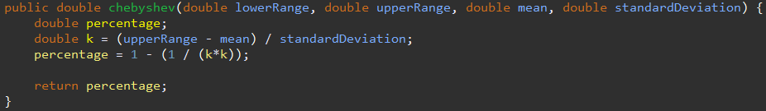

Probability Given Variance

* Given a lower range of 16, upper range of 24, mean = 20, and variance = 4

Output:

Chebyshev Given Variance Method:

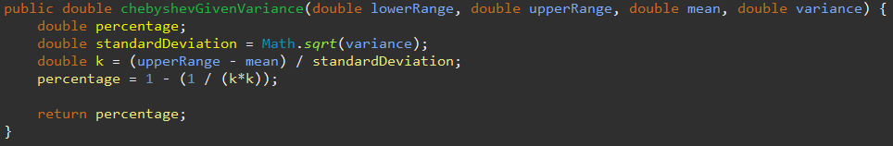

Uniform Distribution

Probability

* Given the desired interval has an upper bound b = 15 and lower bound a = 5 while the overall interval has an upper bound d = 20 and lower bound c = 0

Output:

Uniform Distribution Method:

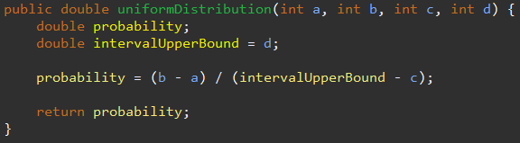

Expected Value

* Given an overall interval with an upper bound d = 20 and lower bound c = 1

Output:

Expected Value Method:

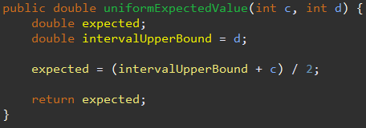

Variance

* Given an overall interval with an upper bound d = 20 and lower bound c = 1



Output:

Variance Method:

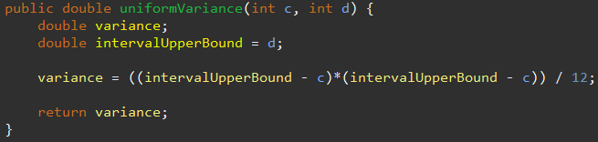

Standard Deviation

* Given an overall interval with an upper bound d = 20 and lower bound c = 1



Output:

Standard Deviation Method:

